

**Meeting Speakers\***

**Gary Procop, MD, MS**

Cleveland Clinic

The Histopathology and Mycology of Fungal Infections and Improving Test Utilization: Better Care at a Lower Cost

**Whitney High, MD, JD**

University of Colorado

Dermatopathology Dilemmas and Medical Legal Pitfalls

**Steven Smith MD**

Medical College of Virginia/Virginia Commonwealth University

Update on WHO Classification of Renal Tumors and

*speaker topics subject to change

**Meeting Registration Form**

Name: ______________________________________ ______ I will attend the Scientific Session

Address: ______________________________________ ______ I will attend the reception

______________________________________

Please mail with registration fees (see reverse) to:**Virginia Society for Pathology**

**c/o Teri Manley 698 Orangewood Dr., Virginia Beach, VA 23453**

**Hotel Information**

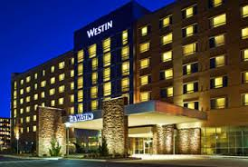

**The Westin Richmond** will be the host hotel for this year’s meeting. A special rate of $139/night for a King room is available. Mention **Virginia Society for Pathology** to obtain this rate.

**Meeting Information**

* Education will take place on Saturday, November 7th
* 6 hrs. of education will be earned upon completion
* Registration includes breakfast, lunch, and reception Saturday afternoon
* Plan on joining Dr. David Smith and Ventana discuss Digital Microscopy Friday night, Nov 6 (separate registration, info coming)

**Virginia Society for Pathology**

**Annual Fall Meeting 2015**

**November 7 The Westin Richmond**

For more information and **to join VSP or register for the meeting**, visit www.vapath.org